Name: Memoona Kiran
Arid no: 23-Arid-821
Section: BSSE-5B M

Develop an Android application that allows users to create and manage study notes, track quiz progress, and maintain user state across OS events. The app must correctly save and restore state during rotation, configuration changes, background/foreground transitions, and low-memory process death. Students must define core features (minimum 10), map each feature to suitable resources/APIs/libraries, and select any three features to implement using one framework of choice (Java & XML, Kotlin, React Native, Flutter, Xamarin, or Kivy). The submission must include technical documentation explaining the implementation and the method used to preserve state across important Android OS events.

Deliverables:
1) List at least 10 features / functional requirements of your project
Create your own feature list relevant to the study-notes/quiz mini-app scenario.

2) Provide a feasibility study
Prepare a table mapping each requirement to available resources/APIs/packages/libraries that would help you implement.

3) Technical developer guide
Choose any three features from your feature list and provide a detailed, step-by-step technical guide on how to implement them.

4) Implementation
Using any ONE of the allowed frameworks (Java & XML / Kotlin / React Native / Flutter / Xamarin / Kivy), implement the three selected features inside a small working project.

Submission Requirements:
- Push your completed mini project to your own GitHub repository.
- Include a short README file describing the added features and navigation flow.
- Prepare screenshots of your project code from android studio, output from emulator or separate device, and your git repository along with feasibility study to include in your submission document.
Class Activity
Deliverable 1: Feature List / Functional Requirements
Project Title
Study Notes & Quiz Management Android Application
Feature List (Minimum 10)
- Create Study Notes
Users can write and save short study notes inside the app.
- Edit Existing Notes
Users can update previously saved notes.
- Delete Notes
Users can remove notes they no longer need.
- View All Notes
Users can see a list of all saved study notes.
- Quiz Creation
Users can create simple quizzes related to their study topics.
- Attempt Quiz
Users can attempt quizzes and select answers.
- Quiz Score Calculation
The app automatically calculates quiz scores after submission.
- Quiz Progress Tracking
The app keeps record of attempted quizzes and scores.
- State Preservation on Screen Rotation
The app preserves entered data during screen rotation and configuration changes.
- Persistent Data Storage
Notes and quiz progress remain saved even after closing and reopening the app.
- Simple User-Friendly Interface
The app provides an easy-to-use and clean user interface.
- Offline Access
All notes and quizzes are accessible without internet connection.
Deliverable 2: Feasibility Study
Feasibility Study Table
(Mapping Requirements to Android Resources / APIs)

Feature / Requirement | Android Resource / API / Library | Feasibility
Create Study Notes | EditText, Button, TextView | High
Edit Notes | EditText, View Binding | High
Delete Notes | Button, Kotlin Logic | High
View All Notes | RecyclerView | Medium
Quiz Creation | EditText, LinearLayout | Medium
Attempt Quiz | RadioButton, RadioGroup | Medium
Quiz Score Calculation | Kotlin Programming Logic | High
Quiz Progress Tracking | SharedPreferences | High
State Preservation (Rotation) | onSaveInstanceState(), Bundle | High
Persistent Storage | SharedPreferences / Room Database | High
User Interface Design | XML Layouts | High
Offline Functionality | Local Storage APIs | High

Deliverable 3: Technical Developer Guide
Development Environment
- IDE: Android Studio
- Language: Kotlin
- UI Design: XML Layouts
- Minimum Android Version: API 21 (Android 5.0)

Selected Features for Implementation
The following three features are selected from the feature list:
- Create and display study notes
- Preserve app state during screen rotation
- Save notes permanently using local storage

Feature 1: Create and Display Study Notes
Objective
Allow the user to write a study note and display it on the screen when the save button is clicked.

Step-by-Step Implementation
Step 1: Create User Interface (XML)
- Open activity_main.xml
- Use a LinearLayout
- Add:
  - EditText for note input
  - Button to save note
  - TextView to display note
Key Components Used
- EditText → User input
- Button → Trigger save action
- TextView → Display saved note

Step 2: Write Kotlin Logic
- Open MainActivity.kt
- Link UI components using findViewById
- Set a click listener on the save button
- Read text from EditText
- Display it in TextView
Result
When the user enters text and clicks the save button, the note appears on the screen.

Outcome
✔ User can successfully create and view study notes.

Feature 2: Preserve App State During Screen Rotation
Objective
Ensure that the entered or displayed note is not lost when the device screen is rotated.

Problem Explanation
Android destroys and recreates the activity during screen rotation, causing data loss if state is not saved.

Step-by-Step Implementation
Step 1: Override onSaveInstanceState()
- Save the current note into a Bundle
- Use a key-value pair to store the note text

Step 2: Override onRestoreInstanceState()
- Retrieve the saved note from the bundle
- Restore it into the TextView
Android APIs Used
- onSaveInstanceState()
- onRestoreInstanceState()
- Bundle

Outcome
✔ The note remains visible even after screen rotation or configuration change.

Feature 3: Persistent Storage Using SharedPreferences
Objective
Save the study note permanently so it remains available even after closing and reopening the app.

Step-by-Step Implementation
Step 1: Save Data to SharedPreferences
- Access SharedPreferences using getSharedPreferences()
- Store the note using putString()
- Apply changes using apply()

Step 2: Load Saved Data on App Start
- Read stored note from SharedPreferences
- Display it inside the TextView during onCreate()
Android APIs Used
- SharedPreferences
- MODE_PRIVATE

Outcome
✔ Notes are saved permanently and restored when the app is reopened.

Scenario | Solution Used
Screen Rotation | onSaveInstanceState
App Background | SharedPreferences
Process Death | SharedPreferences

Conclusion
The three implemented features demonstrate:
- Basic CRUD functionality
- Proper handling of Android lifecycle events
- Reliable data persistence using local storage
These techniques ensure a stable and user-friendly Android application.

4) Implementation:

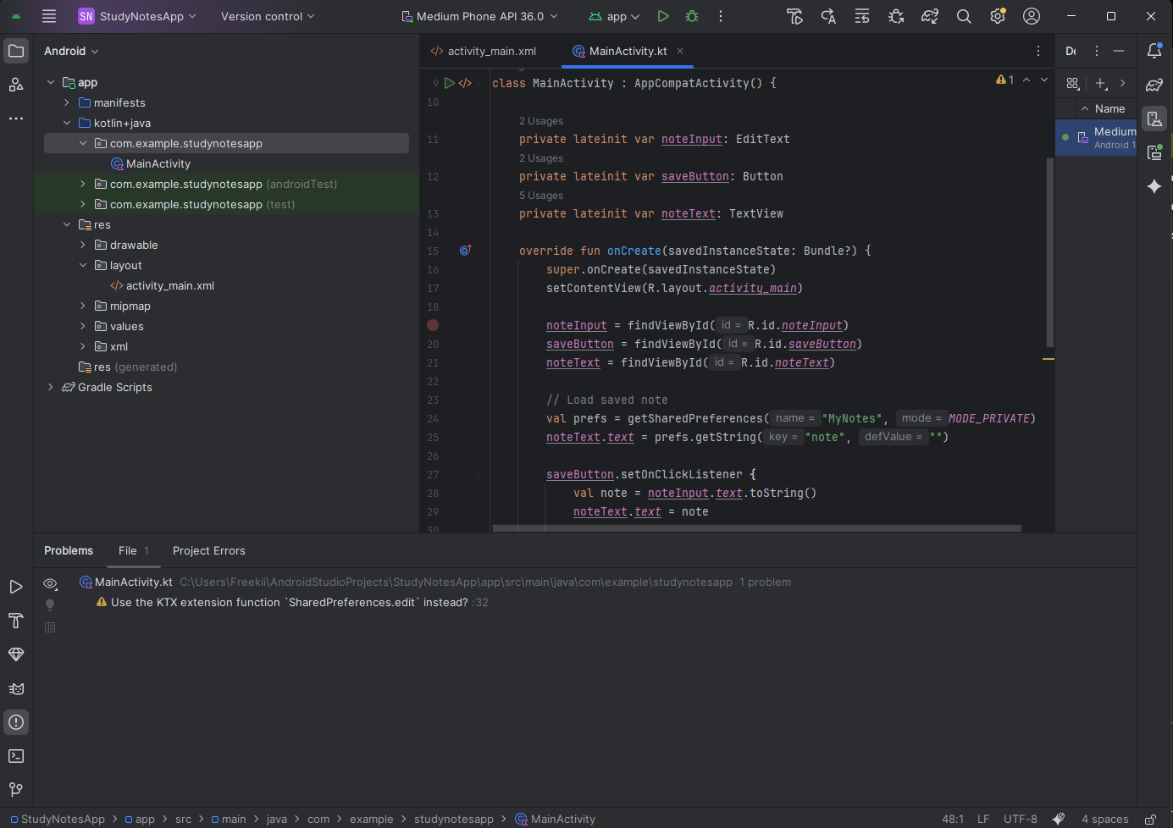
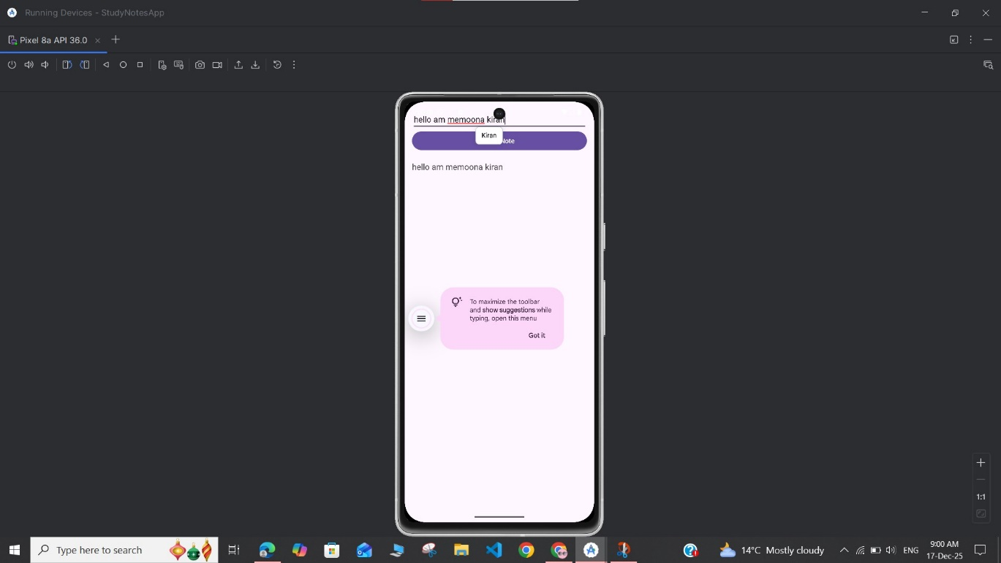

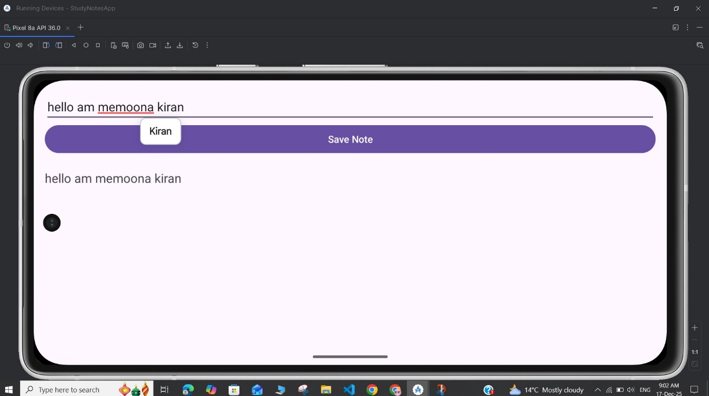

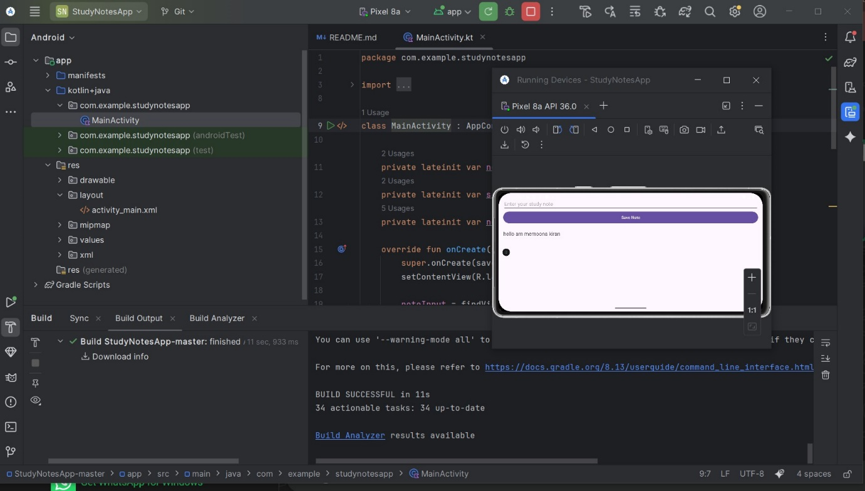

Git repository Link: https://github.com/Muzaffar-Ali-Shah/StudyNotesApp.git

